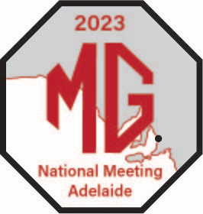
2023 MG National Meeting 7-11 April
November Update
www.natmeet2023mgcc.com.au/

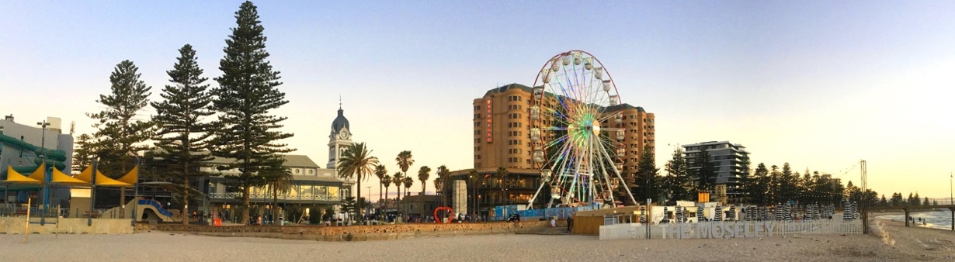
Octagonal Greetings!

Lots more detail for you in this edition of the Update – and more than 170 Expressions of Interest to date.

Supplementary Regulations are being finalised and will be posted on the National Meeting website once they are approved by Motorsport Australia.

Details of Registration categories for Adelaide next year are listed below. These are different to previous National Meetings following decisions made at the 2022 Delegates Meeting.

Category | Description
Social | Social registration allows you to attend all Social Events (including meals) but you cannot enter a car in the Concours. You can participate in the Rocker Cover Racing, Social Run and the Kimber Run.
Social Junior aged 12 – 16
Social Junior aged 5 - 11
Social Junior aged less than 5
Competition – Concours Only | Competition - Concours Only registration allows you to enter one car in the concours and attend all Social Events (including meals, the Kimber run and the Social Run).
Competition - Full | Competition - Full registration allows you to participate in all social events as well as the Concours, Motorkhana, Super Sprint or Observation Run.
Competitor Junior aged 12 - 16 | Competition - Junior aged 12 - 16 registration allows a person aged between 12 and 16 on January 1, 2023, to participate in all social events as well as the Concours, Motorkhana, and Super Sprint or Observation Run.

The Concours is amongst the first events of the National Meeting, and will be held at Wigley Reserve, Glenelg on Saturday April 8th. Cars need to be in position by 9.15. Judging begins at 10.00am and Class winners will be announced as soon as the class judging is completed.

The Observation Run and Social Run will end with lunch at the Lobethal Bierhaus who are also a sponsor and have arranged a special National Meeting bottling of a fine brew as a souvenir of the event.

And speaking of lunches, the Kimber Run will end with lunch at the Hahndorf Oval. If you haven’t been before, this Adelaide Hills town is a prime tourist spot and well worth a lengthy wander during the afternoon.

Regalia is being produced and as always, orders can be placed as part of the registration process. You will not be able to purchase regalia during the National Meeting.

The National Meeting website is a primary source of information and contacts for the event and is updated as more details become available, so check it out at www.natmeet2023mgcc.com.au

Also check out the website for registration and full details. Entries are expected to be open at the end of December and will close at the end of February. In the meantime, you can lodge an expression of interest or send enquiries to our Registrar, Chris Bray, at Registrar2023natmeet@adam.com.au People who have lodged an expression of interest will be notified via e-mail as soon as registrations open.

And if you haven’t booked your accommodation, I urge you to get onto it ASAP! Adelaide is hosting the AFL Magic Weekend featuring all teams from April 13th – 16th (the weekend after Easter) and as this also falls within School Holidays from most Eastern states there is likely to be very strong demand for hotel/motel rooms. The Stamford Grand at Glenelg, for example, is filling up fast. Straight after the footy is the LIV Golf Tournament at Grange which will put further pressure on accommodation.

There has been a request from visitors for Trailer parking over Easter, and Peter Micklem in Hahndorf has some space available. His contact details are pbmicklem@gmail.com or 0411238514. The Bend Motorsport Park has also confirmed trailers can be left there but at owners’ risk.

There will be another update in December with full details of registration, closing dates for entries etc. In the meantime please send any enquiries to:

Tim Edmonds, President, Chairman2023natmeet@adam.com.au
Chris Bray, Registration, Registrar2023natmeet@adam.com.au
Sandra Cardnell, Secretary2023natmeet@adam.com.au

See you in Adelaide next Easter!!

Cheers,
Tim Edmonds
President, MG Car Club of SA.

